Lab 6 (2%)

Getting started with MongoDB

Learning outcomes

Upon successful completion of this workshop, you will have demonstrated the abilities to:

1. Create a mongoDB document using key:value pairs.
2. Define values of different data types within a mongoDB document.
3. Insert a mongoDB document into a collection within the test database.
4. Run simple commands to retrieve one document of a collection within the test database.
5. Group work acknowledgment

We, Divnoor Singh Bhandohal and Sophia Huynh, declare that the attached assignment is our own work in accordance with the Seneca Academic Policy. No part of this assignment has been copied manually or electronically from any other source (including web sites) **or distributed to other students.**

Specify below what each member has done towards the completion of this work:

Name Task(s)

1. Divnoor Singh Bhandohal 4-8
2. Sophia Huynh 1-4

MongoDB installation and use

1. Download and install MongoDB community edition.

Follow the instructions in the link below. <https://docs.mongodb.com/manual/tutorial/install-mongodb-on-windows/>

* + Download MongoDB Community Edition installer.
  + Run the MongoDB installer.
  + Follow the MongoDB Community Edition installation wizard
    - Choose Setup Type: complete
    - Service Configuration: Windows service
    - Run the service as Network Service user
  + From Windows Explorer/File Explorer, go to C:\Program Files\MongoDB\Server\4.4\bin\ directory and double-click on [mongo.exe](https://docs.mongodb.com/manual/reference/program/mongo/#bin.mongo).

Instructions

You are to write mongoDB commands in the mongoDB shell to create a new database, populate a collection, and insert a document into the collection.

1. Display the database you are using. Type db

The operation should return test, which is the default database.

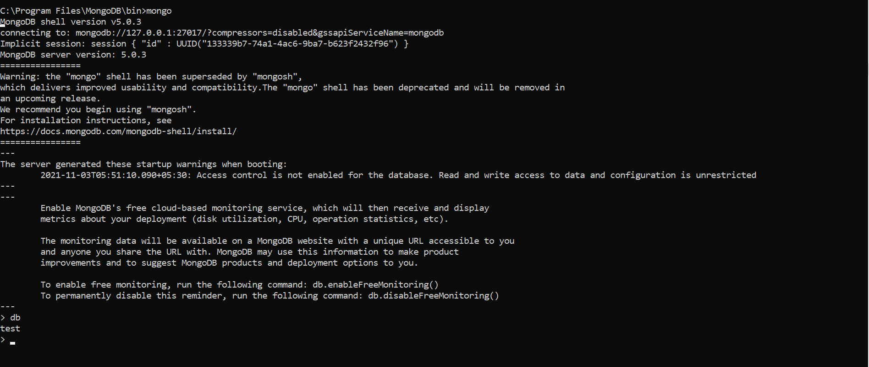

1. Switch to database called lab6. Type use lab6

Even if it is non-existing, MongoDB will create a database called lab6. Type again db

The operation should return lab6

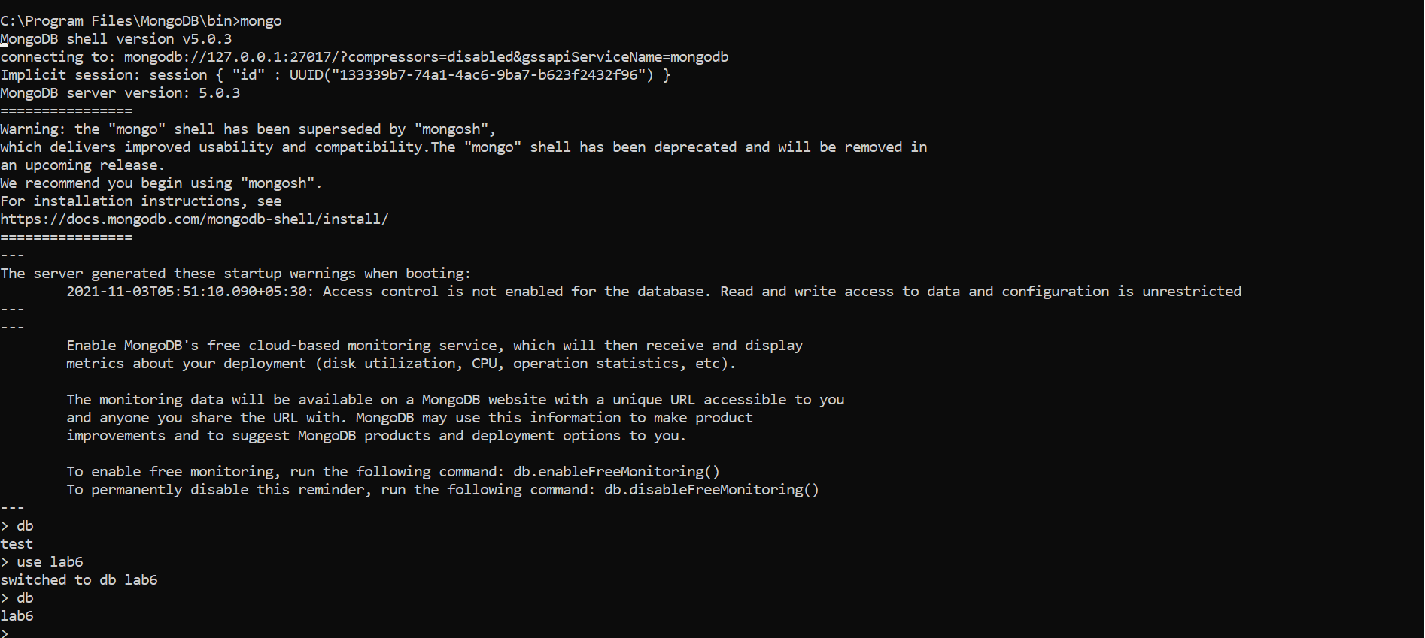

1. Use insert() to insert the following item in the products collection.

|  |  |  |  |  |  |  |  |  |
| --- | --- | --- | --- | --- | --- | --- | --- | --- |
| code | desc | indate | qoh | min | price | Colors | Size | Package |
| 11QER/31 | Power painter, 15 psi., 3-nozzle | 2011-11-03 | 100 | 5 | 109.99 | Black, red | l: 24  w:19.99  h:14.99  uom: "cm" | weight: 1.79 uom: "kg" |



1. Use findOne() and show the document in the products collection. Use pretty() for formatting.

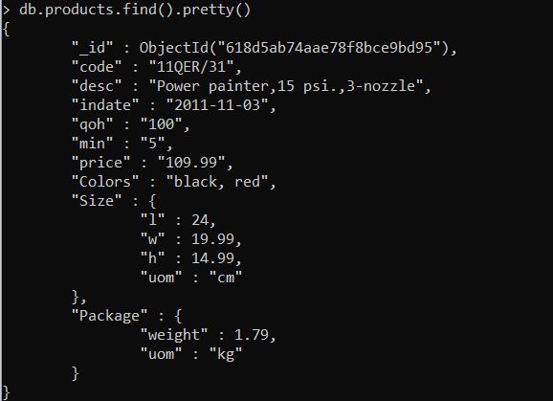

1. Use insertMany() to bulk insert the following items in the products collection. When the data is missing for a specific attribute, the document should not contain that attribute as key in its structure.

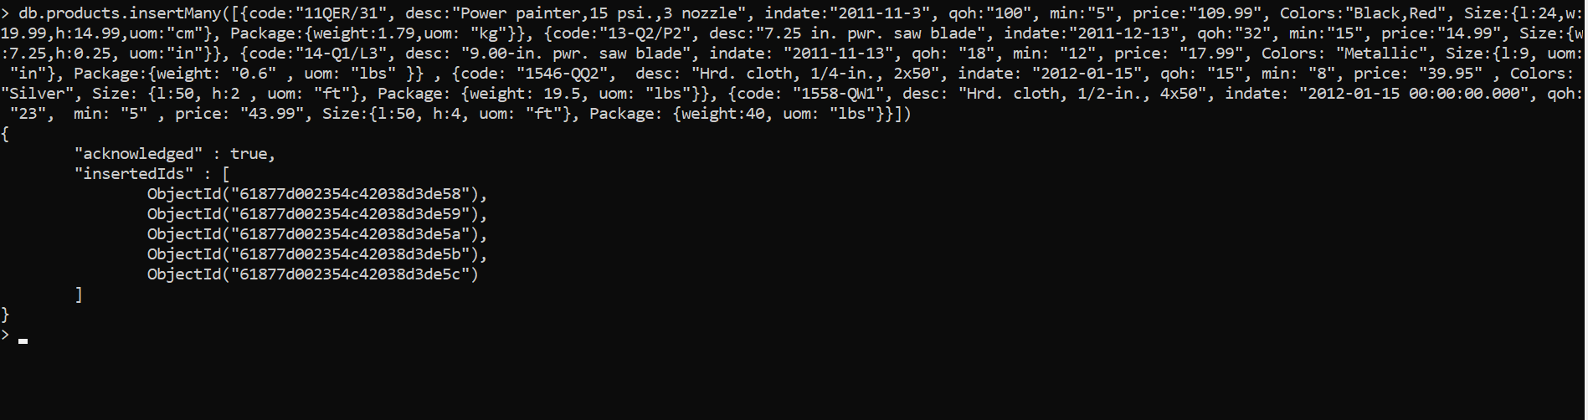

|  |  |  |  |  |  |  |  |  |
| --- | --- | --- | --- | --- | --- | --- | --- | --- |
| code | desc | indate | qoh | min | price | Colors | Size | Package |
| 13-Q2/P2 | 7.25-in. pwr. saw blade | 2011-12-13 | 32 | 15 | 14.99 | - | w: 7.25  h: 0.25  uom: in | - |
| 14-Q1/L3 | 9.00-in. pwr. saw blade | 2011-11-13 | 18 | 12 | 17.49 | Metallic | l: 9  uom: in | weight: 0.6  uom: lbs |
| 1546-QQ2 | Hrd. cloth, 1/4-in., 2x50 | 2012-01-15 | 15 | 8 | 39.95 | silver | l:50  h:2  uom: ft | weight: 19.5  uom: lbs |
| 1558-QW1 | Hrd. cloth, 1/2-in., 4x50 | 2012-01-15 00:00:00.000 | 23 | 5 | 43.99 | - | l:50  h:4  uom: ft | weight: 40  uom: lbs |

1. Show all inserted documents in the products collection. Use find() an pretty() function for formatting.

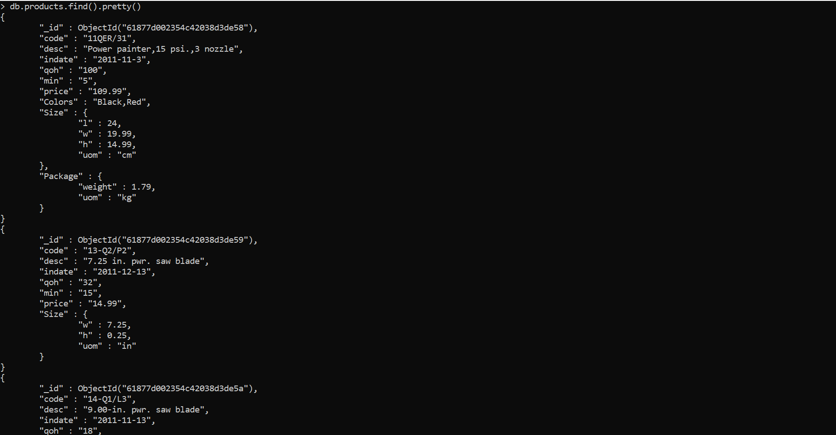

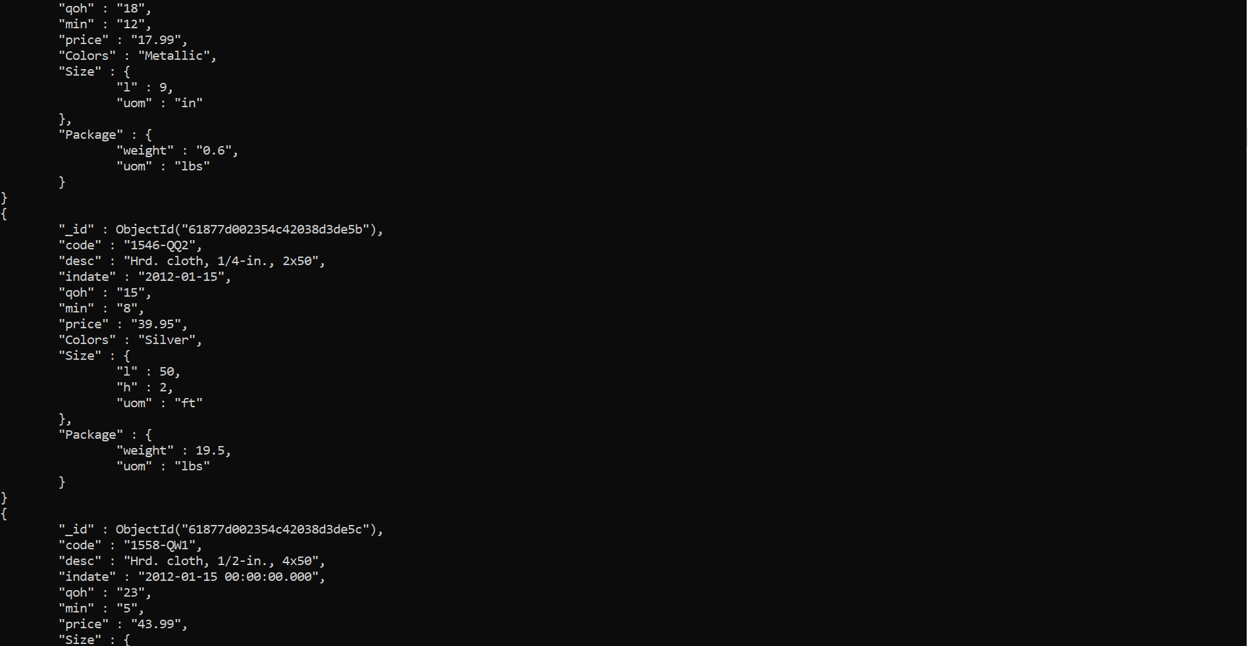

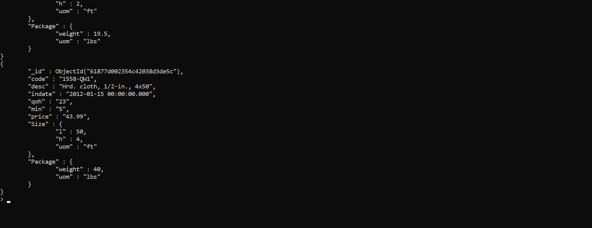

1. What is the bson size in Bytes of the document returned by calling the findOne() function.
   * 266



1. Remove product 11QER/31 from the products collection. Use the remove function and use code as key. Show all documents in the products collection. Use find() an pretty() function for formatting. Make sure product 11QER/31 does not exist.

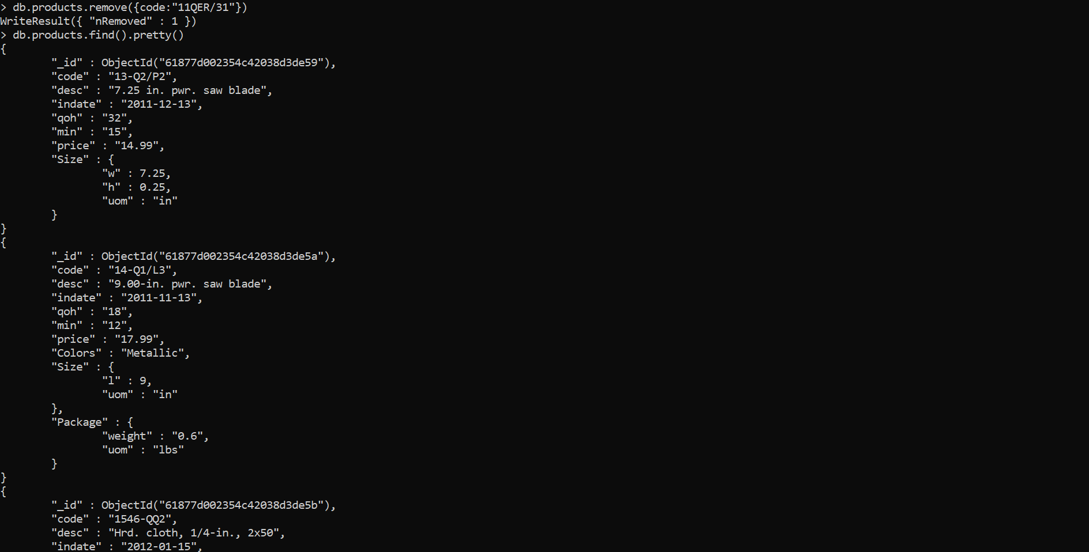

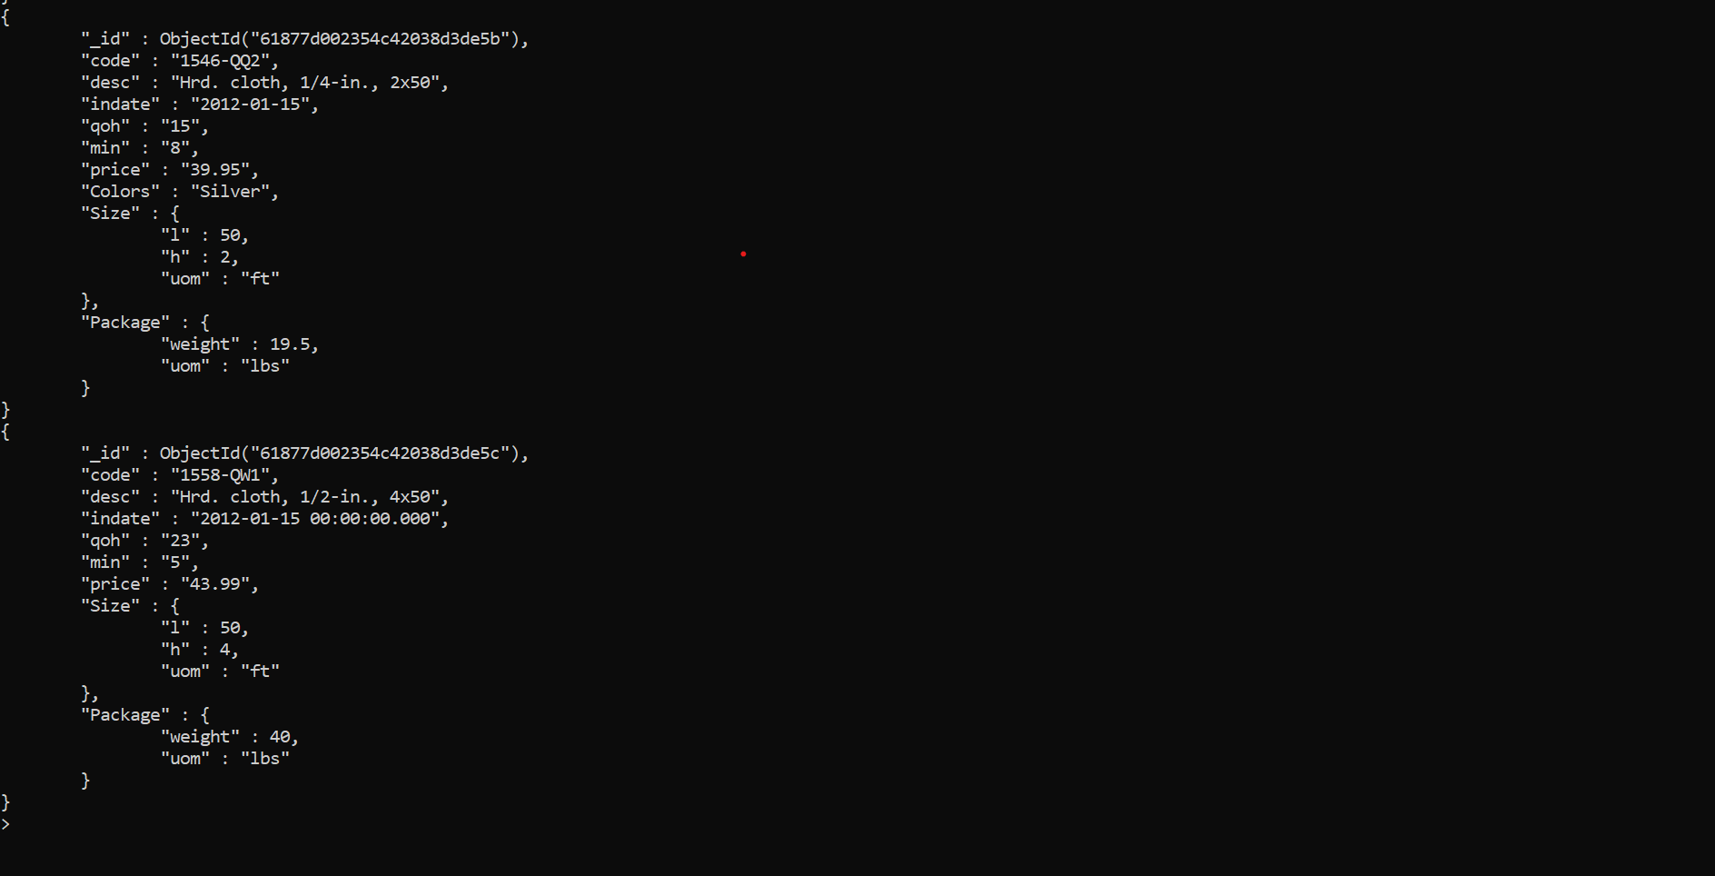

SUBMISSION

Each question is worth 5 pts.

Submit your lab6_GroupX.doc file on BB. Replace X with your group number.

If a student does not contribute to the work, do not list his/her name(s) under the group section in the lab file and will get 0.